COPSP Fellows Assignments to RET Teachers 2016-17
COFSP Fellow/ Field of Engineering Teacher Contact / Discipline School Information
James Fiorini  Mechanical Engineering |  | John D’Alessandro - Comprehensive Physics, Grade 12, AP Physics C  Mike Day –  Algebra 1 Grades 9 and 10, Advanced Pre-Calculus Grade 11, Discrete Math Grade 12, Statistics A, Statistics B, and an intro to Engineering class Grades 11, 12 | St. Xavier High School  600 W. North Bend Road  Cincinnati, Ohio 45224 Phone: (513) 761-7600  Reading High School  810 E. Columbia Ave.  Reading, Ohio 45215  Phone: (513) 733-4422
Neah Gray  Environmental Engineering | 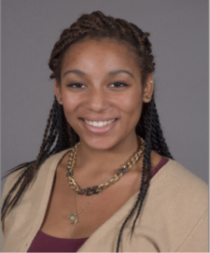 | Amy Parker  Honors Physics Grades 11 and 12, Biology 10, Environmental Science, Grades 11 and 12 | Finneytown High School 8916 Fountainebleau Terrace,  Cincinnati, OH 45231  Phone: (513) 728-3706
Jacob Knorr  Biomedical  Engineering | 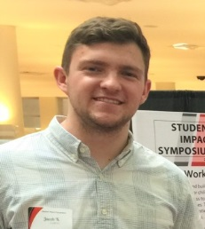 | Samantha Lafin  Clean Energy Technology and Engineering Grade 9, Biology Grade 10 | Scott High School  5400 Old Taylor Mill Road  Taylor Mill, Kentucky, 41015  Phone: (859) 356-3146
Chirau Patel  Aerospace l Engineering |  | John D’Alessandro - Comprehensive Physics, Grade 12, AP Physics C  Jim Prugh - Advanced Pre-Calculus, Algebra 1 Grade 9 | St. Xavier High School  600 W. North Bend Road  Cincinnati, Ohio 45224  Phone: (513) 761-7600  Indian Hill High School 6865 Drake Rd.  Cincinnati, OH 45243 Phone (513) 272-4550
Lydia Smoot  Aerospace l Engineering | 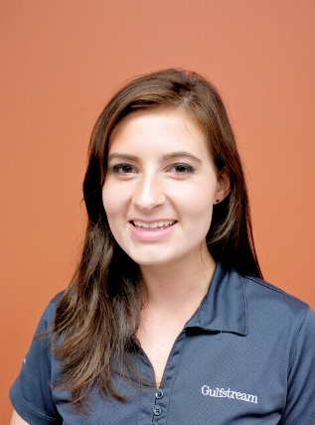 | Mike Day –  Algebra 1 Grades 9 and 10, Advanced Pre-Calculus Grade 11, Discrete Math Grade 12, Statistics A, Statistics B, and an Intro to Engineering class Grades 11 and 12 | Reading High School  810 E. Columbia Ave.  Reading, Ohio 45215  Phone: (513) 733-4422
Emma Stumpf  Biomedical Engineering | 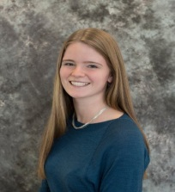 | Nancy Vossen  Biology 9, Zoology 11 and 12  Sam Mizener  CP Algebra 1 Grade 9, Geometry Grade 10, Programming 9-12 | Kings High School  5500 Columbia , Rd.,  Kings Mills, OH 45040  Phone: (513) 398-8050

